DASHBOARD
Dashboard Description
A dashboard titled was created by combining all the analytical worksheets developed in Tableau.
The dashboard provides a complete overview of:
• Country-wise Economic Freedom Score
• Relationship between Economic Freedom and GDP per Capita
• Regional distribution of economic freedom
• Comparison of economic indicators across countries
• Employment and inflation comparison
• Identification of high-performing and low-performing economies
The dashboard integrates multiple visualizations into a single interactive analytical interface to help users understand how institutional and policy factors influence economic prosperity.
Interactive Filters
Interactive filters were added for:
• Country
• Region
• Economic Indicator
These filters allow users to dynamically explore data and perform customized analysis without modifying the dataset.

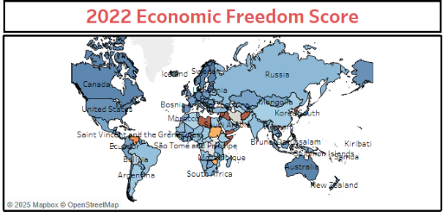
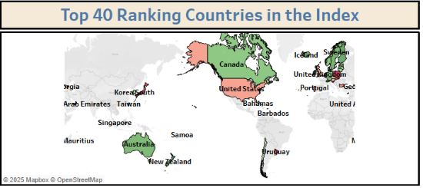
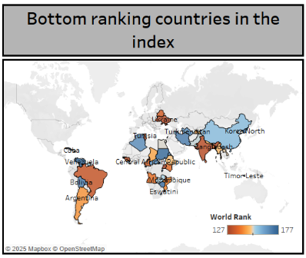
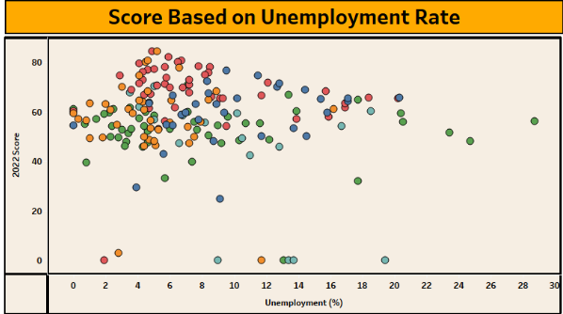
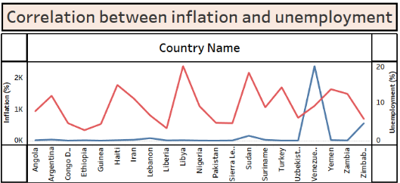
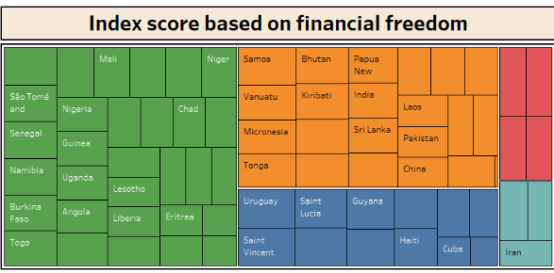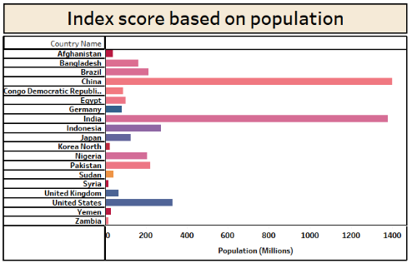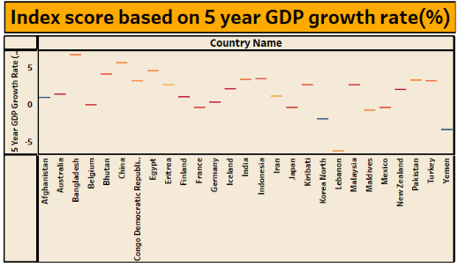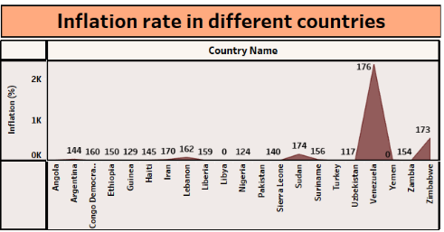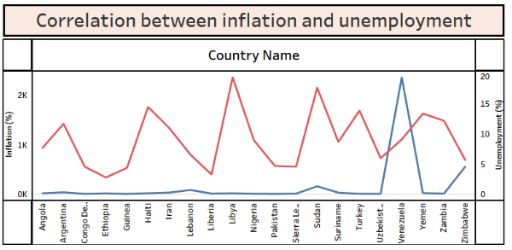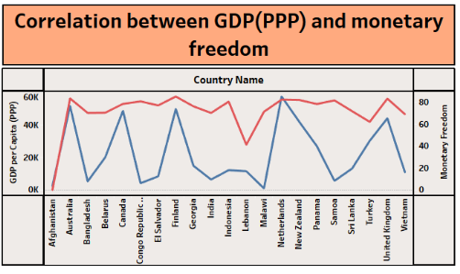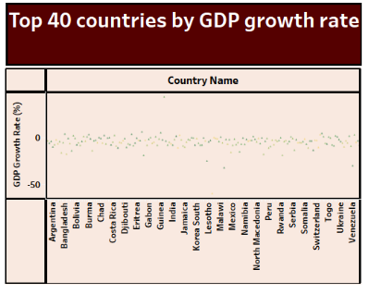

Reference Link:
https://public.tableau.com/app/profile/lakshmi.supriya.jonnalagadda/viz/MyDashboards_17509586290130/Dashboard1

Reference Link:
https://public.tableau.com/app/profile/chalamalasetti.gopi/viz/SmartBridge/To yCraftTalesTableausVisionintoToyManufacturerData

